# A close-up of a logo Description automatically generatedA logo with a rainbow and text Description automatically generated with medium confidenceA black and white background with a black corner Description automatically generatedMawang: Guide to developing an Indigenous evaluation framework

September 2024

This Mawang (altogether) guide will help you develop an evaluation framework for your organisation. The framework is a guide for all evaluations carried out by your organisation. It helps you understand what is required when an evaluation framework will involve or effect Aboriginal and Torres Strait Islander people.

Then you can use our Gulbarra (understanding) guide to help you develop a plan for a specific evaluation. It will help you work out how to design an evaluation plan. See ..’

This template provides a series of prompts to be answered, preferably by the main stakeholders in the evaluation. If more than one group of people is involved, it may take a series of meetings.

The evaluation framework has four elements – agreement-making, gathering, sorting and sharing. You can work through them one at a time.

Figure 1: Yulang’s four elements of evaluation

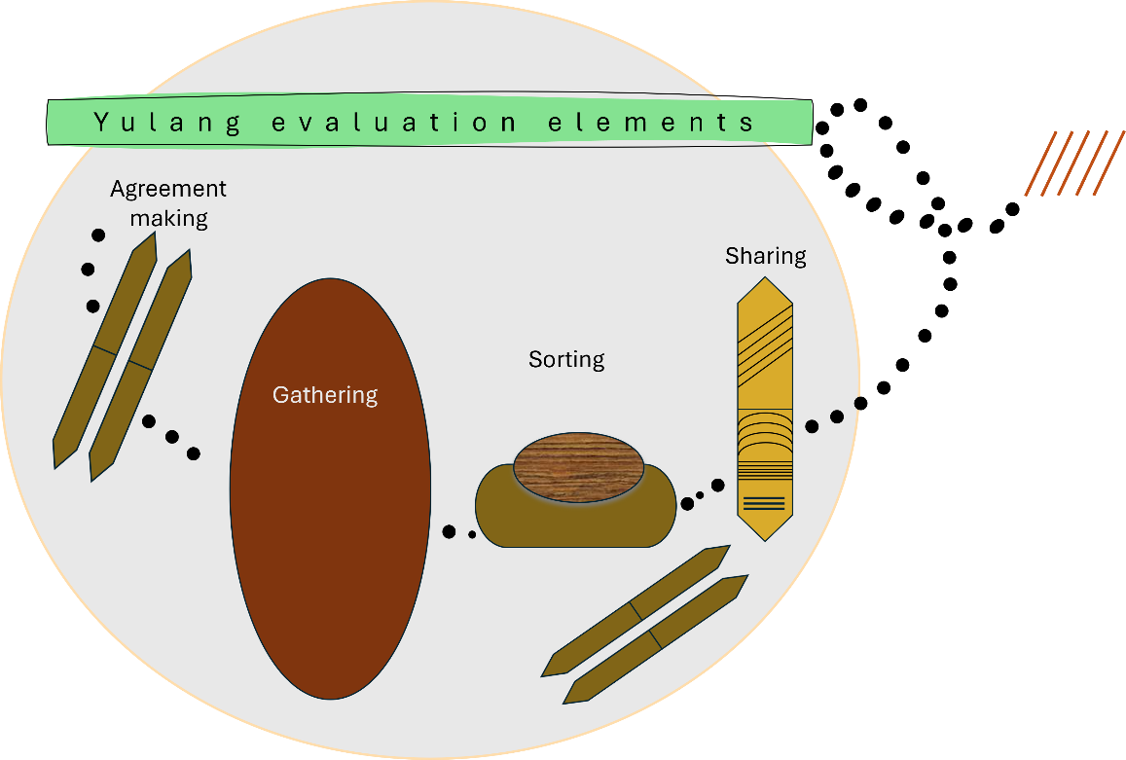

This section describes a shared agreement about the principles, practices and context of the evaluation framework. Write your answer in the space under each question.

|  |
| --- |
| What is the purpose of the evaluation framework? |
| Write here |
| Who are the parties to this evaluation framework? |
|  |
| What is covered by this evaluation framework, and what is not? |
|  |
| What principles are to be enacted in any evaluation? |
|  |
| What guidelines need to be taken into account for any evaluation? |
| * National statement on ethical conduct in research 2023 (NHMRC) * Code of ethics for Aboriginal and Torres Strait Islander research (AIATSIS, 2020) * First Nations cultural safety framework (Australian Evaluation Society, 2021) * Please add any more |
| How Aboriginal and Torres Strait Islander ways of knowing, being and doing be embedded from program/project leadership to organisational management? |
|  |
| How will the priorities, objectives and strategies of Aboriginal and Torres Strait Islander community partners be supported in any evaluation? |
|  |
| How will Aboriginal and Torres Strait Islander peoples’ right to self-determination be supported in any evaluation? |
|  |
| How will Indigenous data sovereignty and governance be enacted in any evaluation? |
|  |
| What power differentials need to be taken into account in any evaluation? |
|  |
| What will be done to ensure that any evaluation takes place in accordance with anti-discrimination legislation and is actively anti-racist in practice, supported by cultural safe practices? |
|  |
| Will any evaluation be designed to consider workforce development and capacity building? |
|  |
| Will any evaluation be designed to consider truth telling and healing? |
|  |
| How will any evaluation be designed to use decolonising methodologies? |
|  |
| Will any evaluation be designed to strengthen relationships between Indigenous people? |
|  |
| Will any evaluation be designed to strengthen relationships to culture and to Country? |
|  |
| What process was followed to reach this shared understanding? |
|  |
| How will further decisions about this evaluation framework be made? |
|  |
| What governance arrangement exist for this evaluation framework? |
|  |

This section provides a broad summary of the data gathering requirements of an evaluation framework. Write your answer in the space under each question.

|  |
| --- |
| Will any evaluation have a specific, measurable, achievable, realistic and time-bound aim? |
|  |
| Will any evaluation have clear objectives? |
|  |
| Will any evaluation include the perspectives of participants or end-users, as well as that of the organisation? |
|  |
| Will any evaluation take into account the multiple levels at which empowerment of Indigenous people should occur: system, community, organisational, program and individual experiences and factors? |
|  |
| Mixed-methods evaluation is recommended for evaluations with Indigenous people; will any evaluation be required to include both qualitative data and quantitative data (where possible) in order to gather a rounded picture? |
|  |
| Will data collection with Aboriginal and Torres Strait Islander people take place? |
|  |
| Will the views and perspectives of Aboriginal and Torres Strait Islander community and/or other end-users will be represented? |
|  |

This section provides a broad summary of the data analysis and learnings requirements of an evaluation framework. Write your answer in the space under each question.

|  |
| --- |
| What groups of people should be represented in any data analysis? Will Aboriginal and Torres Strait Islander people be involved? |
|  |
| What critical reflection tool/s will be used? |
|  |

This section provides a broad summary of the reporting and knowledge transfer requirements of an evaluation framework. Write your answer in the space under each question.

|  |
| --- |
| Will learnings from any evaluation be shared with those involved with and affected by the policy or program? |
|  |
| Given Indigenous people take seriously intergenerational knowledge transfer as a cultural protocol, a range of diverse strategies, and their resourcing, are required over time. What strategies will you use? |
|  |
| Will achievements be recognised? |
|  |
| Will ongoing relationships with community partners be supported? |
|  |

Once complete, you can either leave this framework in the question and answer format (but remover all text in this font), or you can re-write your answers into a narrative or visual form, using the framework headings agreement-making, gathering, sorting and sharing.

To remind you, this Mawang guide to developing an Indigenous evaluation framework, which is a guide to how any evaluation in an organisation will be carried out.

To develop an evaluation plan for a particular evaluation, use the Gulbarra guide to developing an evaluation plan.

## Suggested citation

Williams, M., Ragg, M. & Marlin, D. (2024). *Mawang guide to developing an Indigenous evaluation framework.* Yulang Indigenous Evaluation. https://yulang.com.au/starburst-indigenous-evaluations/mawang

## Contact

|  |  |  |  |
| --- | --- | --- | --- |
|  | Megan Williams [megan.williams@yulang.com.au](mailto:megan.williams@yulang.com.au) 0400 073 358 |  | Mark Ragg [mark.ragg@yulang.com.au](mailto:mark.ragg@yulang.com.au) 0404 017 507 |