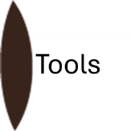
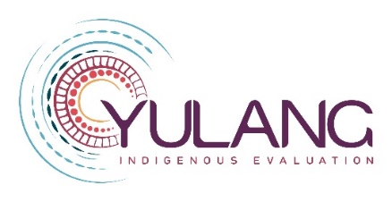

Gulbarra: Guide to developing an Indigenous evaluation plan

September 2024
This Gulbarra (understanding) guide will help you develop an evaluation plan for your evaluation. It helps you understand how you will carry out a particular evaluation of a policy or program that involves or effects Aboriginal and Torres Strait Islander people.
This Gulbarra guide is best used after you have used the Mawang guide to developing an Indigenous evaluation framework. That will have set up how you will approach any evaluation within your organisation – this will guide you as to what you will do in a particular evaluation.
This template provides a series of prompts to be answered, preferably by the main stakeholders in the evaluation. If more than one group of people is involved, it may take a series of meetings.
The plan has four elements – agreement-making, gathering, sorting and sharing. You can work through them one at a time.
Figure 1: Yulang’s four elements of evaluation
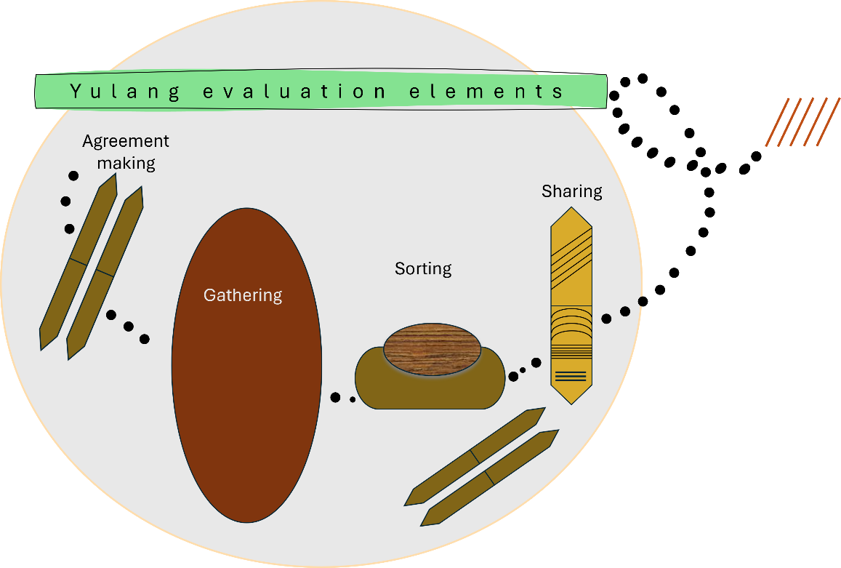

Agreement-making 
This section describes a shared agreement about the principles, practices and context of the evaluation framework. Write your answer in the space under each question.
Using Mawang, you will already have described:
- the purpose of the evaluation
- the principles to be enacted
- the guidelines to be taken into account
- how Aboriginal and Torres Strait Islander ways of knowing, being and doing are embedded
- how the priorities, objectives and strategies of Aboriginal and Torres Strait Islander communities involved will be supported
- how Aboriginal and Torres Strait Islander peoples’ right to self-determination will be supported
- how Indigenous data sovereignty and governance will be enacted
- how power differentials will be taken into account
- to What will be done to ensure that any evaluation takes place in accordance with anti-discrimination legislation and is actively anti-racist in practice, supported by cultural safe practices?
- How will further decisions about this evaluation framework be made?
Now please answer the following questions.

Who are the parties to this evaluation?
What is covered by this evaluation, and what is not?
How will Aboriginal and Torres Strait Islander ways of knowing, being and doing be embedded from program/project leadership to organisational management?
How will the priorities, objectives and strategies of Aboriginal and Torres Strait Islander community partners be supported in any evaluation?
How does this evaluation consider workforce development and capacity building?
How does this evaluation consider truth telling and healing?
How does this evaluation strengthen relationships between Indigenous people?
How does this evaluation strengthen relationships to culture and to Country?
What process was followed to reach this shared understanding?
What governance arrangement exists for this evaluation?
Please provide positionality statements for each person involved in this evaluation, including in design, data collection, analysis and interpretation
What critical reflection tool/s will be used?

Gathering 
This section provides a broad summary of the requirements of an evaluation plan. Write your answer in the space under each question.
What is the specific, measurable, achievable, realistic and time-bound aim of this evaluation?
What is the objective of this evaluation?
How will the perspectives of participants or end-users, as well as that of the organisation, be taken into account?
How does this evaluation take into account the multiple levels at which empowerment of Indigenous people should occur: system, community, organisational, program and individual experiences and factors?
Mixed-methods evaluation is recommended for evaluations with Indigenous people. What qualitative and quantitative methods will be used to gather data in order to gather a rounded picture?
How will data collection with Aboriginal and Torres Strait Islander people take place?
How will the views and perspectives of Aboriginal and Torres Strait Islander community and/or other end-users will be represented?
What are the risks and limitations of the methods?
Is formal ethics clearance needed?

Sorting 
This section discusses the data analysis requirements of an evaluation plan. Using Mawang, you will already have described the groups of people to be included in the analysis. Write your answer in the space under each question.

What process will be followed for data analysis? How will Aboriginal and Torres Strait Islander people be involved?
What process will be followed for data analysis? How will Aboriginal and Torres Strait Islander people be involved?
What process will be followed to agree on learnings? How will Aboriginal and Torres Strait Islander people be involved?
Will recommendations be made? If so, how? And how will they be followed up to see if they are implemented?

Sharing
This section provides a broad summary of the reporting and knowledge transfer requirements of an evaluation framework. Write your answer in the space under each question.

How will learnings from any evaluation be shared with those involved with and affected by the policy or program?
Given Indigenous people take seriously intergenerational knowledge transfer as a cultural protocol, a range of diverse strategies, and their resourcing, are required over time. What strategies will you use?
How will achievements be recognised?
Will recommendations be made? If so, to who? And how will they be followed up to see if they are implemented?
How will ongoing relationships with community partners be supported?

Once complete, you can either leave this framework in the question and answer format, or you can re-write it into narrative form.
Remove all text in this font.
To remind you, this Gulbarra guide to developing an Indigenous evaluation plan, which is a guide to how any evaluation in an organisation will be carried out.
It should not be used in isolation, but should operate within the bounds of an Indigenous evaluation framework. If you do not have one, please use Mawang – Yulang’s guide to developing an Indigenous evaluation framework, at https://yulang.com.au/starburst-indigenous-evaluations/mawang

Suggested citation
Williams, M., Ragg, M. & Marlin, D. (2024). Gulbarra guide to developing an Indigenous evaluation plan. Yulang Indigenous Evaluation. https://yulang.com.au/starburst-indigenous-evaluations/gulbarra/
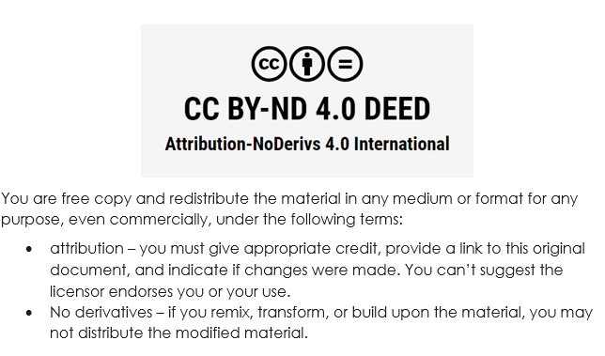

Contact
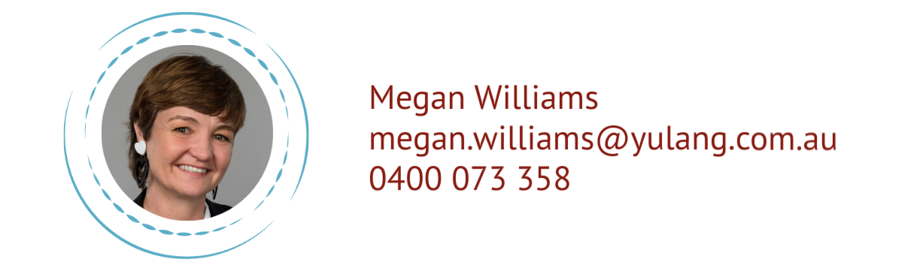 | Megan Williams  megan.williams@yulang.com.au  0400 073 358 | 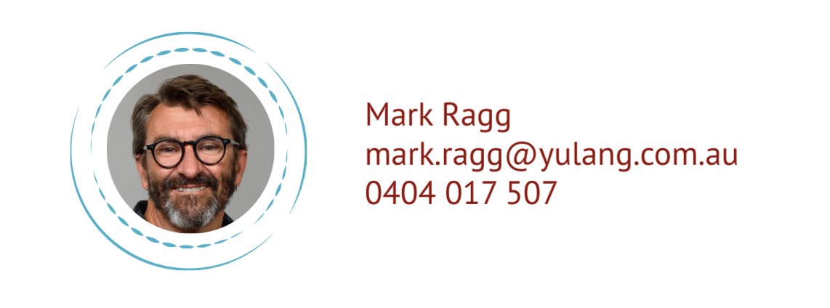 | Mark Ragg  mark.ragg@yulang.com.au  0404 017 507

